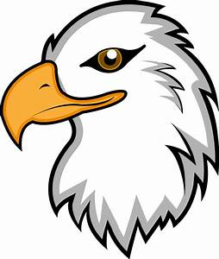

Freedom Life Academy Photo Release

Freedom Life Academy (FLA) would appreciate your permission to use your child’s photographed, videotaped, and/or filmed image in one or more of the following ways:
- In stories and other informational materials, promotions, and advertisements published in newspapers, brochures, and other print media
- In videotaped or otherwise recorded informational and/or promotional materials
- On the school’s website, Instagram, Twitter, and/or FB page.

There is no monetary compensation for the use of your child’s image, but it will help FLA to generate and maintain interest in its programs and activities. Please sign the following release to grant FLA permission to use your child’s image as set forth below.

Parent/Guardian Release
I hereby authorize Freedom Life Academy as follows:

- to photograph and record my child, ______________________________________ on film, video tape, or otherwise image
- to edit any image
- to use any image, alone or with the images of others, in a reasonable manner (including, but not limited to, the uses described above).

I acknowledge and understand the following:

- that using my child’s image as set forth herein involves releasing it unto the public domain
- that FLA owns all rights in and to all images
- that no monetary compensation will be given to me or to my child for the use of any image
- that my child’s name may be included in the information, if needed

Freedom Life Academy takes this matter seriously. We will not use these photos in a reckless manner that would expose our students to unnecessary risks.

________ Yes, I agree for FLA to use the image of my child.

________ No, I do not agree for FLA to use the image of my child.

Parents’ Signature: _____________________________________________________________

Printed Name: _________________________________________________________________

Date: ________________________________________________________________________

